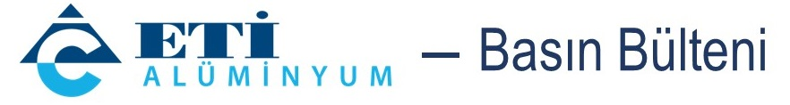 14 November 2025

Eti Alüminyum contributes 37,900 saplings to Türkiye’s forest assets on National Afforestation Day
Combining sustainable mining with environmental responsibility, Eti Alüminyum planted a total of 37,900 saplings through afforestation activities carried out at the Bayavşar and Karabulak sites as part of National Afforestation Day on November 11. Through this initiative, the company contributed to both protecting biodiversity and creating new carbon sink areas capable of offsetting approximately 490 tons of carbon emissions annually.
As one of the leading producers in Türkiye’s aluminum industry, Eti Alüminyum carried out a large-scale afforestation event at the Bayavşar Mining Site and Karabulak Site under the leadership of Chairman of the Board Ekrem Cengiz and Vice Chairman Şaban Cengiz on National Afforestation Day.Within the scope of the afforestation efforts, 16,400 saplings were planted at the Bayavşar Mining Site and 21,500 saplings at the Karabulak Site, bringing the total to 37,900. Among the planted species were almond, cypress, aronia, plane tree, and horse chestnut, as well as various other species such as juniper, alder, oak, mulberry, catalpa, rosehip, and mountain medlar, ensuring high ecological diversity.
CARBON EMISSIONS OF 220 VEHICLES TO BE OFFSET ANNUALLY
This comprehensive initiative by Eti Alüminyum not only helps create new green areas but also contributes to combating climate change by increasing the region’s carbon sink capacity. As the planted trees grow, approximately 490 tons of carbon are expected to be removed from the atmosphere annually — an amount equivalent to the annual carbon emissions of around 220 vehicles.
In addition to the afforestation efforts, special areas were designated on-site for the cultivation of endemic species. These areas were designed to protect natural habitats, support genetic diversity, and ensure the long-term impact of ecological rehabilitation.

‘ACTING IN HARMONY WITH NATURE IS NOT JUST A RESPONSIBILITY’
Commenting on the initiative, Eti Alüminyum General Manager Mehmet Arkan stated: “Acting in harmony with nature while carrying out our mining operations is not only a responsibility for us but also part of our corporate culture. Each sapling is a symbol of our commitment not only to the environment but also to the future. At Eti Alüminyum, we have adopted the principle of returning the resources that the soil provides back to the soil itself. The afforestation activities we carried out on November 11 are the concrete reflection of this philosophy. We will continue our efforts with determination to leave a more livable environment for future generations.”

ABOUT ETİ ALÜMİNYUM:
Founded in 1967 and operational since 1973, Eti Alüminyum has been operating under Cengiz Holding, one of the leading industrial groups in Türkiye, since 2005. Following its privatization, the facilities underwent extensive modernization, capacity expansion, and technological investment, with more than USD 700 million invested to date. Thanks to these investments, Eti Alüminyum now operates the only integrated facility in Türkiye capable of carrying out production from mine to final product. The facility produces 82,000 tons of aluminum annually, which is used in a wide range of sectors from window profiles to aircraft and from tourism to defense industries.

