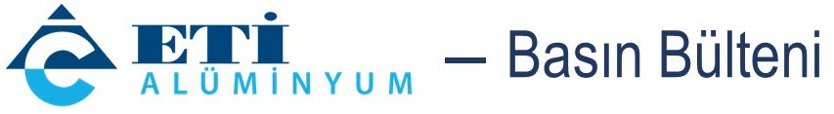
August 9, 2022

Eti Alüminyum’s project to receive funding from Horizon Europe 2020
The ERA-MIN 3 project “Utilization of Aluminum-Barin Raw Materials for the Production of Aluminum Metal, Other Metals and Compounds”, in which Eti Alüminyum will work with companies and universities from three different countries, has been awarded funding under the Horizon Europe 2020 Grant Programme.
Contributing to reducing the country’s current account deficit by producing for strategic industries in Türkiye, Eti Alüminyum continues to pioneer the sector, particularly with R&D and innovation efforts. Eti Alüminyum has qualified to receive funding from Horizon Europe 2020, EU’s key funding program for worldwide scientific knowledge production and creation of collaborations between universities and industries, for the project titled “Utilization of Aluminum-Barin Raw Materials for the Production of Aluminum Metal, Other Metals and Compounds” which the company will realize in partnership with Swedish and Czech companies and universities. Eti Alüminyum, Istanbul Technical University (ITU) and Yeditepe University will work together on the Turkish leg of the project, also supported by TÜBİTAK.
Mehmet Arkan, General Manager of Eti Alüminyum underlined that they are the only integrated facility in Türkiye to produce primary aluminum from ore and said, “Our company, established 49 years ago, has attained an important place in Türkiye and in the world by combining half a century of experience and know-how with technology and R&D after joining Cengiz Holding in 2005. While offering new products developed through R&D to strategic sectors in Türkiye, we undertake major projects with our ongoing innovative work. We are proud that this project, with which we aim to find an alternative to bauxite ore – the world’s primary source of aluminum – has been deemed worthy of EU funding.”

‘BAUXITE DECLARED A CRITICAL RAW MATERIAL’

Underlining that bauxite ore is the world’s primary source of aluminum, Arkan added that bauxite, 90% of which is found in tropical and subtropical regions, has been declared a critical raw material by the EU, “[…] which signifies the importance of bauxite to the sustainability of the global economy and industry.” Arkan continued as follows: “While bauxite reserves are decreasing, the disposal of red sludge is another major item on the agenda. With this project, we will try to produce aluminum from various compounds like alumina, aluminum oxide and low-grade secondary materials, taking into account regional characteristics in Central Europe and Türkiye. Of course, this will make us focus on designing and developing flexible multi-product metallurgical processes. We will analyze a great multitude of raw materials and waste. I believe this will bring important gains in regard to our R&D activities, and I am confident that working with ITU and Yeditepe University in all these processes will contribute greatly to our scientific perspective. I congratulate all my teammates who have been contributing to this project.”

