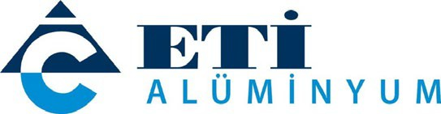

PRESS RELEASE

EDUCATION, INTERNSHIP & EMPLOYMENT OPPORTUNITIES FOR VOCATIONAL HIGH SCHOOL STUDENTS
Eti Alüminyum gives support to education

Eti Alüminyum signed a vocational education cooperation protocol with the Ministry of National Education. Many training activities will be put into action under a program called the 'Eti Alüminyum Development Workshop' aimed at raising more qualified students with better vocational know-how at Seydişehir Vocational and Technical Anatolian High School.
October 19, 2021 – Eti Alüminyum, a subsidiary of Cengiz Holding, has signed a protocol with the Ministry of National Education to improve students’ technical know-how and skills at the Vocational and Technical Anatolian High School in Seydişehir, where its production plants are based. Under the protocol, trainings and workshops will be organized at the high school to enhance the experience-based vocational knowledge of students studying in the departments of Electrical and Electronics Technology, Mechanical and Design Technology, Metal Technology, and Chemical Technology. Eti Alüminyum will support the establishment of laboratories and workshops at the school to contribute to the students’ education. In addition to the trainings that will continue throughout the school year, students will have the chance to do their internship at Eti Alüminyum. Students who successfully complete the program, which also includes scholarships to good learners selected by the Provincial Directorate of National Education, will be given priority in Eti Alüminyum recruitment processes.

‘WE WILL BE THEIR MENTORS’

Briefing about the 'Eti Alüminyum Development Workshop' program, Mehmet Arkan, General Manager of Eti Alüminyum said, “We are aware of our responsibilities as Türkiye's leading company in the aluminum industry. We make significant contributions to regional development by recruiting our staff for Seydişehir Integrated Plant mainly from the local people of Konya and Seydişehir. We support the training of future engineers with the Ahmet Cengiz Engineering Faculty we established at Necmettin Erbakan University and the internship program we offer to students studying there. With this new program, which we have launched in cooperation with the Ministry of National Education General Directorate of Vocational and Technical Education, we will support the vocational training of students at Seydişehir Vocational and Technical Anatolian High School. We will give them access to our plant so that they can apply what they have learned on the job, and we will be their mentors on their path to development.”

PRIORITY IN RECRUITMENT PROCESSES

Vocational development and adjustment courses will be organized as part of the training measures covered by the protocol, along with workshops that build on novel technologies to promote student development in the relevant fields. To foster their vocational development, students will be given the chance to do their compulsory internship at Eti Alüminyum’s Seydişehir Integrated Plant and they will be given priority if they apply for a position at the company after they graduate from high school. Students will also have the opportunity to receive scholarships depending on their level of success.

