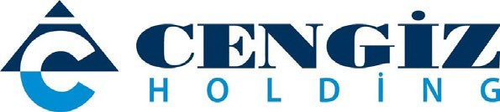

PRESS RELEASE

Cengiz Holding continues to heal the wounds in the regions hit by fire

September 2, 2021 - Cengiz Holding continues to shoulder the efforts to recover the damage caused by forest fires raging across Türkiye.

Cengiz Holding will meet the white goods needs of 50 damaged households in Antalya and Muğla, two of the regions most affected by forest fires. The kitchen appliances that will be delivered to the people in need include 50 refrigerators, washing machines, dishwashers, and freestanding cookers.
Cengiz Holding also donated a pickup truck to the Animal Rights Federation (HAYTAP), which carries out important work for treating animals injured in fire and flood disasters, which the federation will use to transfer animals to rehabilitation centers.
Cengiz Holding, who previously donated USD 5 million to the Disaster and Emergency Management Presidency (AFAD) to support the fight against fires, in addition to equipment for use by field forces, will continue its support to fire-affected regions.

